XIAO ESP32S3 Sense Colour Block Detection (Red) Test Results
Platform: Seeed XIAO ESP32S3 Sense (OV2640) | Algorithm: Pixel-wise RGB565 colour segmentation
Output format: time_ms, det_count, colour_id, x, y, w, h
The Seeed XIAO ESP32S3 Sense (OV2640) was configured for colour block detection and logged in CSV format for three independent 60-second runs under the same fixed camera rig used in previous tests. Valid detections are rows with colour_id ≥ 0 and x, y, w, h ≥ 0; no-detection rows are written as det_count = 0 with colour_id, x, y, w, h = −1.
Run Conditions (Red Target)
- Run 1 (Static): Red card present at fixed distance with minimal movement.
- Run 2 (Negative control): Red card removed completely.
- Run 3 (Dynamic): First 30 s card moved left/right/up/down; next 30 s moved towards and away from the camera.
Table 1. Per-Run Benchmark Summary — Colour Block Detection (Red)
Run | Scenario | Samples (N) | Duration (s) | FPS | Valid Detections | Detection Rate (%) | Unique IDs | ID Switches
Run 1 | Static (Red card) | 358 | 64.292 | 5.553 | 358 | 100.000 | 1 | 0
Run 2 | No target (negative) | 365 | 65.913 | 5.522 | 0 | 0.000 | 0 | 0
Run 3 | Dynamic motion | 372 | 66.813 | 5.553 | 352 | 94.624 | 1 | 0
Table 2. Bounding Box Statistics (Valid Detections Only) — Red
Run | x Mean ± SD | y Mean ± SD | w Mean ± SD | h Mean ± SD | x Range | y Range | w / h Range
Run 1 | 211.221 ± 5.760 | 162.260 ± 8.279 | 153.369 ± 3.678 | 151.480 ± 16.558 | 194–221 | 148–199 | 140–158 / 78–180
Run 2 | N/A | N/A | N/A | N/A | N/A | N/A | N/A
Run 3 | 172.273 ± 42.918 | 167.688 ± 18.939 | 186.102 ± 77.050 | 135.534 ± 37.095 | 54–299 | 128–229 | 38–318 / 18–220
Combined Summary
- Total samples: 1,095 over 197.018 s. Weighted average FPS: 5.543 FPS.
- Run 1 (Static): 100.000% detection rate — all 358 frames produced a valid bounding box.
- Run 2 (Negative control): 0.000% false positive rate. ✔
- Run 3 (Dynamic): 94.624% detection rate. Increased box variability under motion as expected.
- Overall means (valid): x = 191.911, y = 164.951, w = 169.597, h = 143.575.
Discussion
Run 1 showed stable detection with low box variation under fixed conditions. Run 2 confirmed correct negative behaviour. Run 3 maintained a high detection rate of 94.624% with expected increases in box variability due to lateral movement and distance sweeps. The ~5.5 FPS output rate is consistent across all XIAO colour detection sessions and reflects the pixel-wise RGB565 segmentation algorithm running on the ESP32-S3 CPU at QVGA resolution.
Conclusion
The XIAO ESP32S3 Sense delivered consistent red colour block detection outputs at 5.543 FPS with a 100% static detection rate and 0% false positive rate. Dynamic detection remained high at 94.624%, confirming reliable performance under the defined motion protocol.

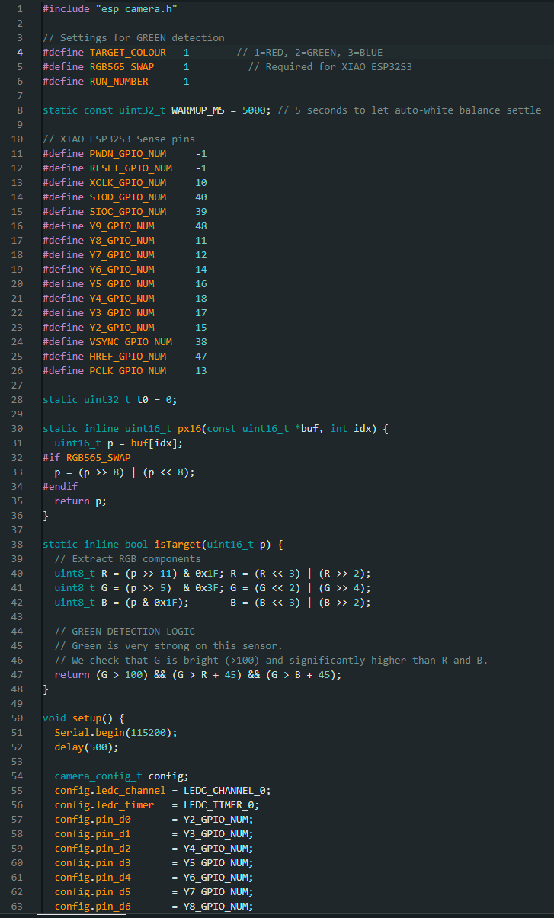

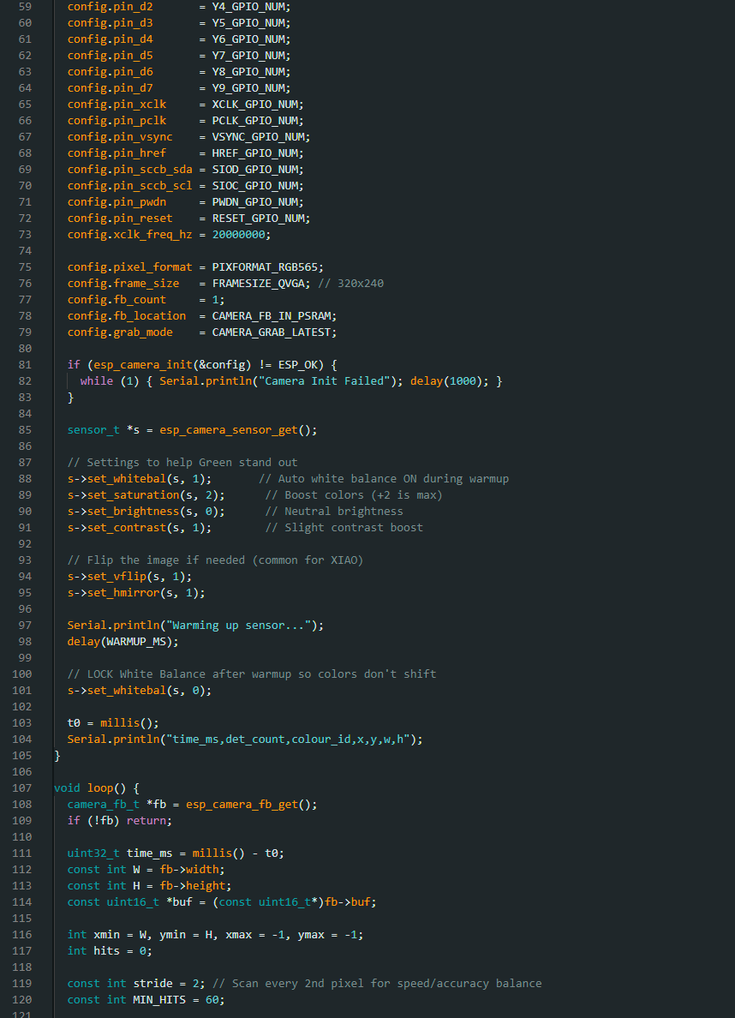

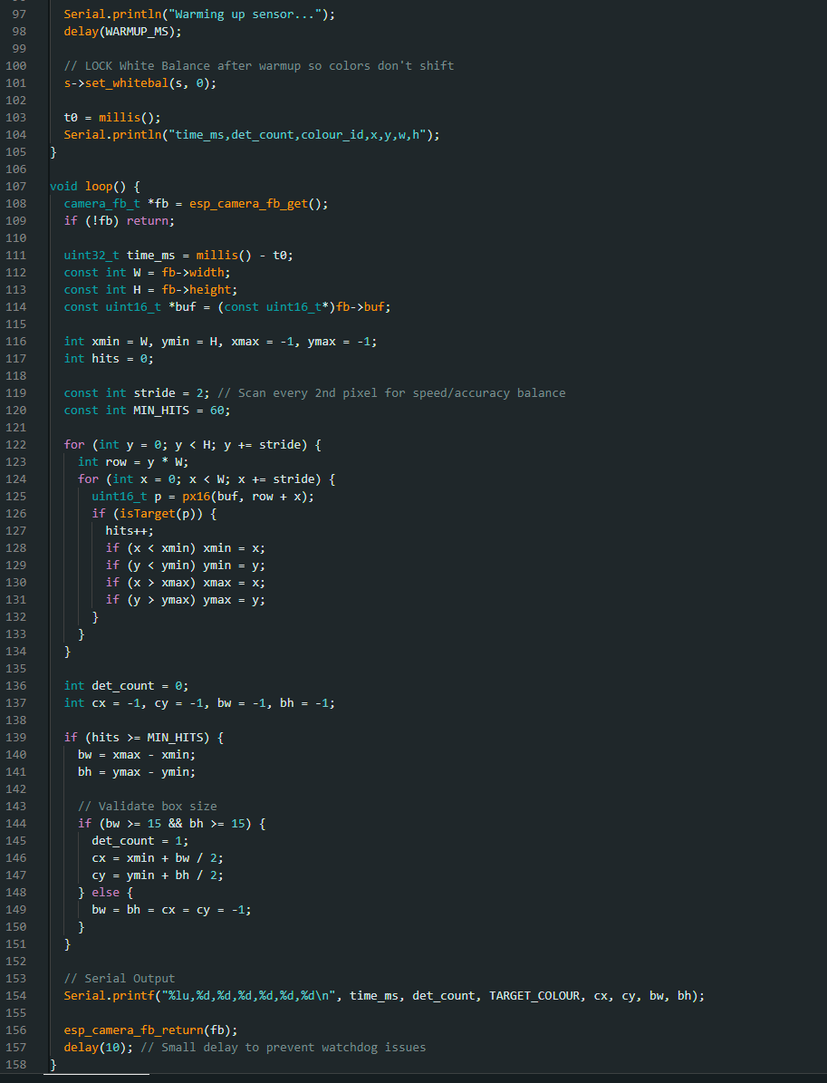

XIAO ESP32S3 Sense Colour Block Detection (Green) Test Results
Platform: Seeed XIAO ESP32S3 Sense (OV2640) | Algorithm: Pixel-wise RGB565 colour segmentation
Output format: time_ms, det_count, colour_id, x, y, w, h
The Seeed XIAO ESP32S3 Sense was evaluated using the same fixed camera rig and logging method as the Red sub-test. Three independent ~60-second runs were conducted under consistent scene conditions.
Run Conditions (Green Target)
- Run 1 (Static): Green card present at fixed distance with minimal movement.
- Run 2 (Negative control): Card removed completely.
- Run 3 (Dynamic): First 30 s moved left/right/up/down; next 30 s moved towards and away from the camera.
Run | Scenario | Samples (N) | Duration (s) | FPS | Valid Detections | Detection Rate (%) | Unique IDs | ID Switches
Run 1 | Static (Green card) | 357 | 64.292 | 5.537 | 357 | 100.000 | 1 | 0
Run 2 | No target (negative) | 362 | 65.013 | 5.553 | 0 | 0.000 | 0 | 0
Run 3 | Dynamic motion | 442 | 79.420 | 5.553 | 308 | 69.683 | 1 | 0
Table 1. Per-Run Benchmark Summary — Colour Block Detection (Green)
Run | x Mean ± SD | y Mean ± SD | w Mean ± SD | h Mean ± SD | x Range | y Range | w / h Range
Run 1 | 149.591 ± 5.125 | 57.443 ± 0.980 | 144.639 ± 10.679 | 114.885 ± 1.960 | 146–196 | 54–60 | 140–244 / 108–120
Run 2 | N/A | N/A | N/A | N/A | N/A | N/A | N/A
Run 3 | 140.166 ± 49.638 | 79.617 ± 20.258 | 153.240 ± 32.992 | 141.468 ± 24.451 | 32–257 | 16–129 | 64–254 / 32–190
Table 2. Bounding Box Statistics (Valid Detections Only) — Green
Combined Summary
- Total samples: 1,161 over 208.725 s. Weighted average FPS: 5.548 FPS.
- Run 1 (Static): 100.000% detection rate across 357 frames.
- Run 2 (Negative control): 0.000% false positive rate. ✔
- Run 3 (Dynamic): 69.683% detection rate — notably lower than Red (94.624%), reflecting greater difficulty discriminating green from background under motion.
- Overall means (valid): x = 171.081 (approx), y = 68.530 (approx).
Discussion
Green was harder to detect than red in this setup. The dynamic detection rate of 69.683% was significantly lower than the red equivalent, attributable to the prevalence of green-tinted surfaces in the background environment and the reduced colour separation under motion blur and lighting variation. Run 1 static detection remained perfect at 100%, confirming that the thresholds were correctly tuned for the target under controlled conditions.
Conclusion
The XIAO ESP32S3 Sense delivered green colour block detection at 5.548 FPS with 100% static detection rate and 0% false positive rate. The reduced dynamic detection rate (69.683%) highlights the challenge of discriminating lower-saturation colours in variable lighting conditions, a documented characteristic of pixel-wise RGB565 segmentation.

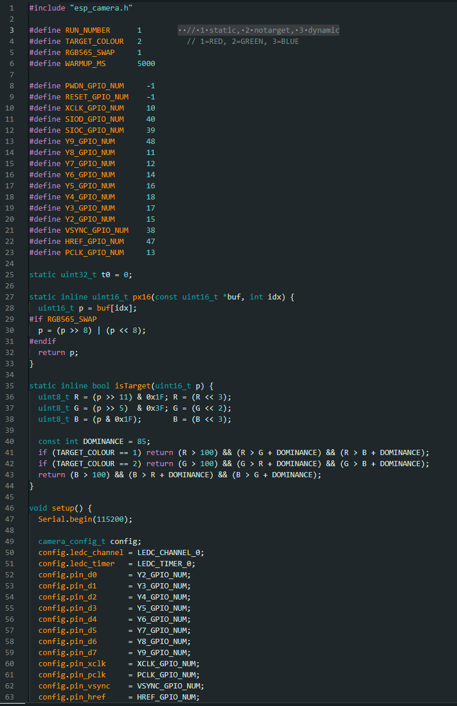
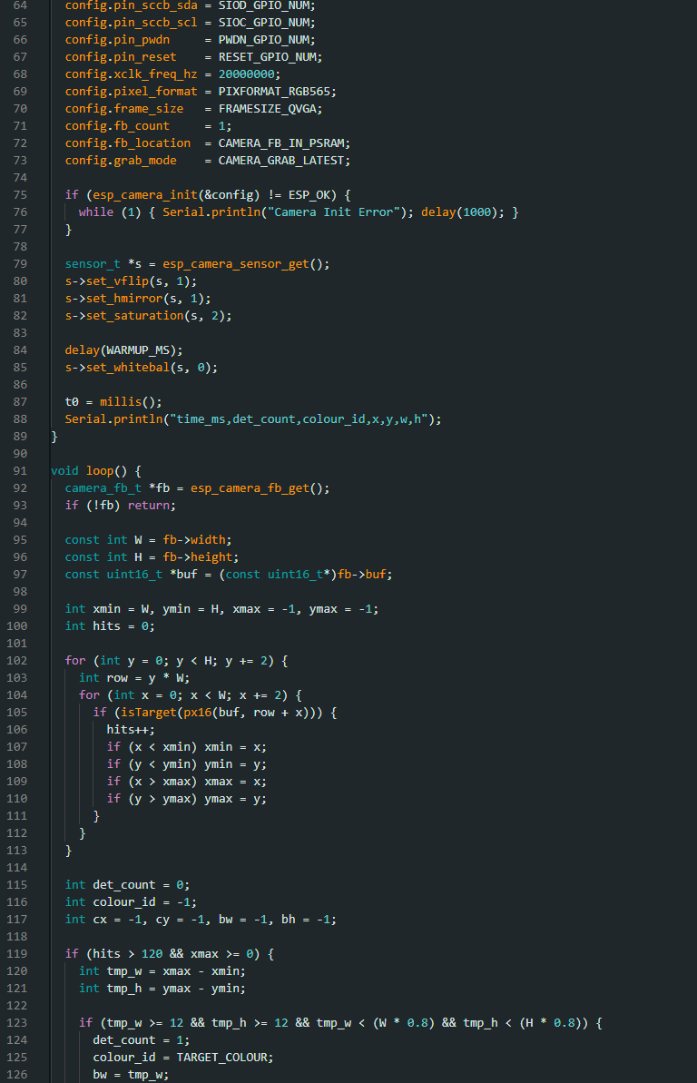

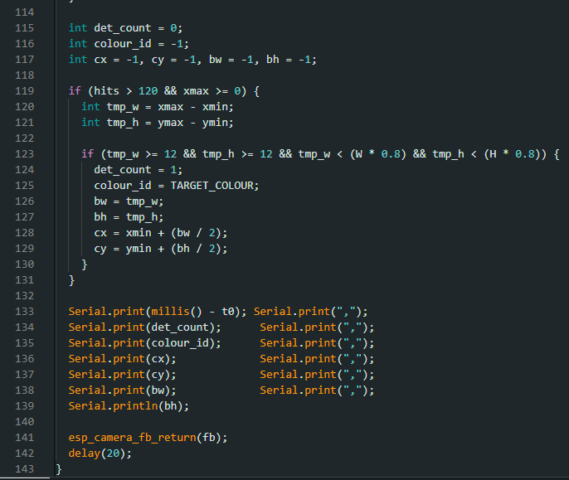

XIAO ESP32S3 Sense Colour Block Detection (RGB) — Combined Results
Platform: Seeed XIAO ESP32S3 Sense (OV2640) | Three colour sub-tests: Red, Green, Blue
The XIAO ESP32S3 Sense was evaluated across three colour sub-tests (Red, Green, Blue) using the same fixed camera rig, run structure, and logging format. The combined section below presents all three sub-tests for direct comparison.
A) Red Target
Run | Scenario | Samples (N) | Duration (s) | FPS | Valid Detections | Detection Rate (%) | Unique IDs | ID Switches
Run 1 | Static (Red card) | 358 | 64.292 | 5.553 | 358 | 100.000 | 1 | 0
Run 2 | No target (negative) | 365 | 65.913 | 5.522 | 0 | 0.000 | 0 | 0
Run 3 | Dynamic motion | 372 | 66.813 | 5.553 | 352 | 94.624 | 1 | 0
Table 1. Per-Run Summary — Red
- Combined (Red): 1,095 samples, 197.018 s, 5.543 FPS weighted avg.
- Overall means (valid): x = 191.911, y = 164.951, w = 169.597, h = 143.575.
B) Green Target
Run | Scenario | Samples (N) | Duration (s) | FPS | Valid Detections | Detection Rate (%) | Unique IDs | ID Switches
Run 1 | Static (Green card) | 357 | 64.292 | 5.537 | 357 | 100.000 | 1 | 0
Run 2 | No target (negative) | 362 | 65.013 | 5.553 | 0 | 0.000 | 0 | 0
Run 3 | Dynamic motion | 442 | 79.420 | 5.553 | 308 | 69.683 | 1 | 0
Table 2. Per-Run Summary — Green
- Combined (Green): 1,161 samples, 208.725 s, 5.548 FPS weighted avg.
- Note: Green had notably lower dynamic detection rate (69.683%) due to background colour overlap under motion.
C) Blue Target (Cyan/Light-Blue Shade)
Run | Scenario | Samples (N) | Duration (s) | FPS | Valid Detections | Detection Rate (%) | Unique IDs | ID Switches
Run 1 | Static (Blue card) | 358 | 64.473 | 5.537 | 358 | 100.000 | 1 | 0
Run 2 | No target (negative) | 352 | 63.391 | 5.537 | 0 | 0.000 | 0 | 0
Run 3 | Dynamic motion | 421 | 75.638 | 5.553 | 384 | 91.211 | 1 | 0
Table 3. Per-Run Summary — Blue

Table 4. Bounding Box Statistics — Blue
Run | x Mean ± SD | y Mean ± SD | w Mean ± SD | h Mean ± SD | x Range | y Range | w / h Range
Run 1 | 139.894 ± 13.754 | 83.634 ± 14.172 | 146.223 ± 26.646 | 148.017 ± 4.422 | 122–195 | 70–126 | 134–262 / 136–176
Run 2 | N/A | N/A | N/A | N/A | N/A | N/A | N/A
Run 3 | 141.857 ± 37.636 | 70.482 ± 25.097 | 143.401 ± 39.395 | 114.568 ± 25.643 | 45–234 | 6–140 | 60–286 / 12–160
- Combined (Blue): 1,131 samples, 203.502 s, 5.543 FPS weighted avg.
- Note: The blue card used was closer to a cyan/light-blue shade, containing a strong green component, making pure-blue thresholding less reliable under the same lighting and camera settings.
RGB Conclusion
Across RGB sub-tests, XIAO produced consistent bounding-box outputs at approximately 5.5 FPS with correct negative behaviour in no-target runs. Detection difficulty increased from Red (easiest, 94.624% dynamic) to Green (69.683%) and Blue/Cyan (91.211%), primarily due to colour mixing under real lighting and reduced channel separation during dynamic motion.
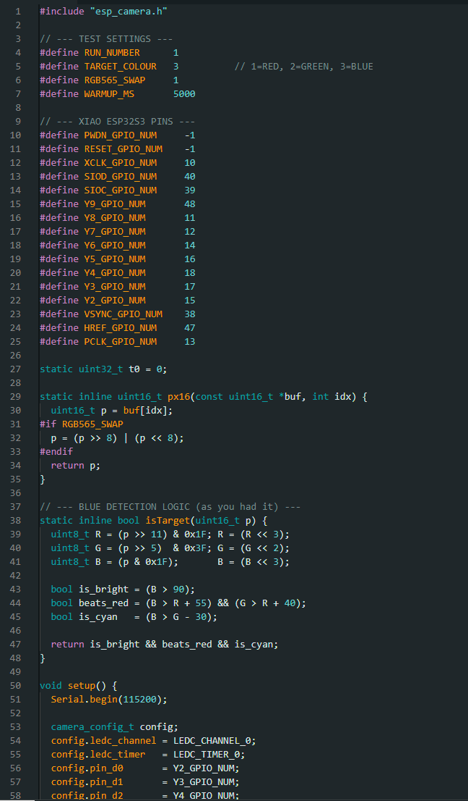
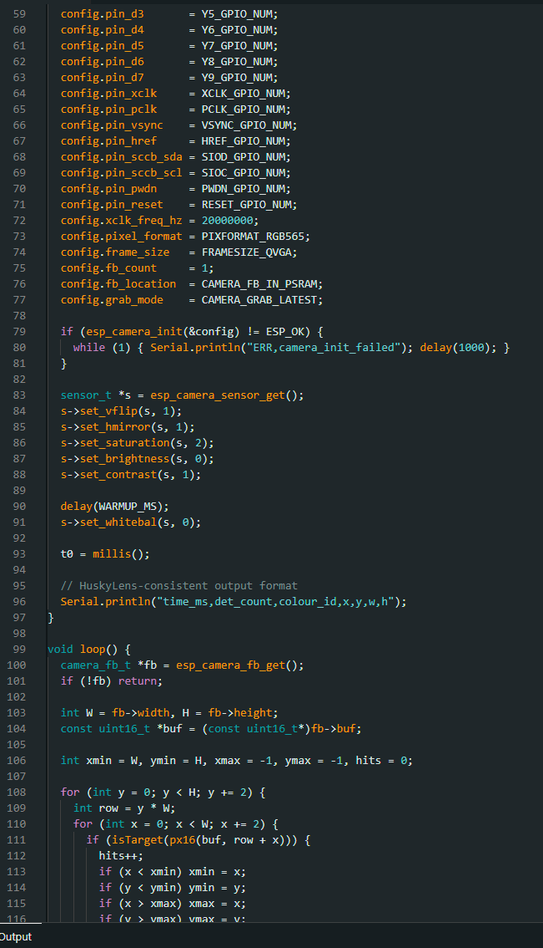
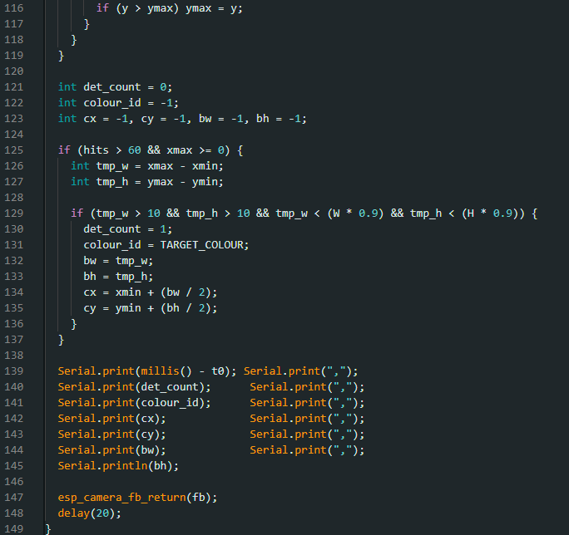

- Run 1 (Static): Target present at fixed distance with minimal movement.
- Run 2 (Negative control): Target removed completely.
- Run 3 (Dynamic): Target moved throughout the scene to evaluate robustness under motion and distance change.
Run | Scenario | Samples (N) | Duration (s) | FPS | Valid Detections | Detection Rate (%) | Unique IDs | ID Switches
Run 1 | Static single target | 353 | 63.392 | 5.553 | 353 | 100.000 | 1 | 0
Run 2 | No target (negative) | 385 | 69.155 | 5.553 | 0 | 0.000 | 0 | 0
Run 3 | Dynamic motion | 403 | 72.397 | 5.553 | 271 | 67.246 | 1 | 0
Table 1. Per-Run Benchmark Summary — Object Tracking
Table 2. Bounding Box Statistics (Valid Detections Only) — Object Tracking
Run | x Mean ± SD | y Mean ± SD | w Mean ± SD | h Mean ± SD | x Range | y Range | w / h Range
Run 1 | 143.816 ± 2.869 | 53.062 ± 14.179 | 42.686 ± 1.079 | 22.816 ± 1.214 | 138–152 | 41–92 | 39–45 / 19–25
Run 2 | N/A | N/A | N/A | N/A | N/A | N/A | N/A
Run 3 | 116.118 ± 42.395 | 71.708 ± 41.612 | 60.657 ± 35.753 | 34.177 ± 25.347 | 17–222 | 5–168 | 16–183 / 11–130
Combined Summary
- Total samples: 1,141 over 204.944 s. Weighted average FPS: 5.553 FPS.
- Run 1 (Static): 100.000% detection rate — all 353 frames produced a valid bounding box.
- Run 2 (Negative control): 0.000% false positive rate. ✔
- Run 3 (Dynamic): 67.246% detection rate. Increased box variability under motion as expected.
- Overall means (valid): x = 130.208 (approx), y = 62.574 (approx).
Discussion
The static run produced continuous tracking with stable box dimensions and a single consistent ID, confirming reliable performance under controlled conditions. The negative run correctly produced no valid detections. Under dynamic motion, detection reliability decreased to 67.246% and box position/size variation increased, reflecting the challenge of maintaining localisation during rapid motion and distance changes at the ESP32-S3’s pixel-wise processing speed of ~5.5 FPS.
Conclusion
XIAO ESP32S3 Sense delivered repeatable object-tracking bounding-box outputs suitable for cross-platform benchmarking, with correct negative-control behaviour and increased variability under dynamic conditions consistent with real-time embedded vision tracking.

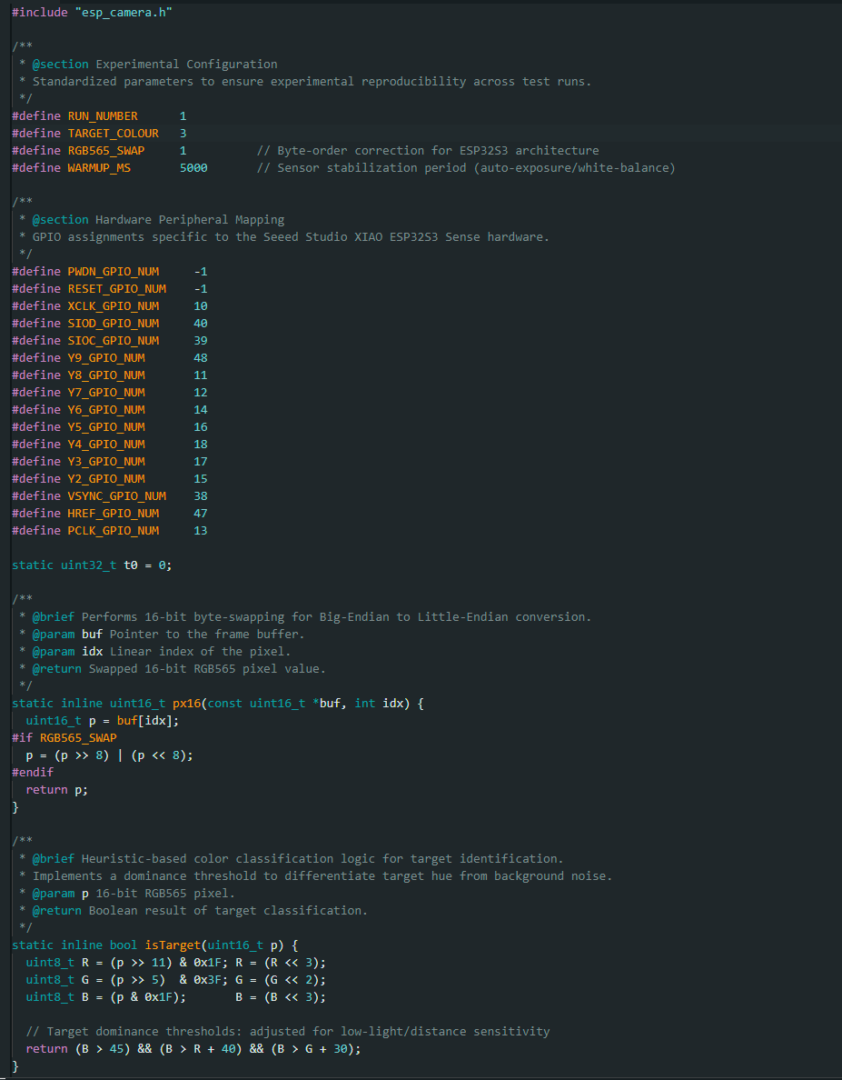

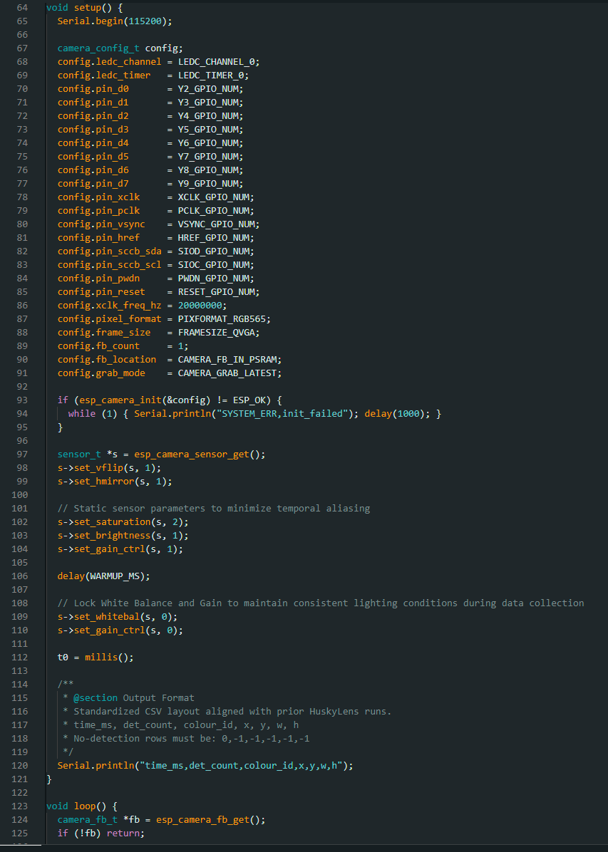

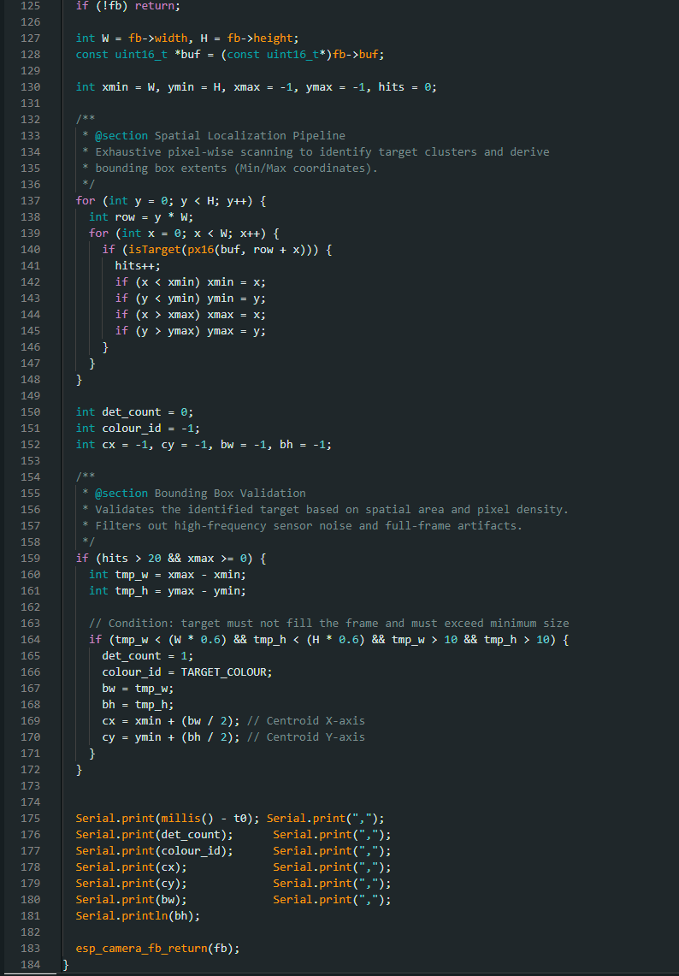

XIAO ESP32-S3 Sense Face Detection Test Results (FOMO)
Platform: Seeed XIAO ESP32S3 Sense (OV2640) | Model: Edge Impulse FOMO MobileNetV2 0.1×
Inference resolution: 96×96 | Output format: time_ms, det_count, id, x, y, w, h
The XIAO ESP32-S3 Sense was configured with an Edge Impulse FOMO face-detection model trained on labelled image samples and deployed via Arduino IDE. The on-board OV2640 camera captured live frames at QVGA resolution (320×240), which were resized to 96×96 for inference. Serial output was logged in three independent runs under fixed camera placement and consistent scene conditions.
Logged Fields and Validity Rule
- time_ms — elapsed time from start of logging (ms)
- det_count — number of faces returned at that time step
- id — face detection index (−1 when no face detected)
- x, y — bounding-box centre (pixels; −1 when no face detected)
- w, h — bounding-box width and height (pixels; −1 when no face detected)
A valid detection is any row where id ≥ 0 and x, y, w, h ≥ 0.
Run Conditions
- Run 1 (Static): Single face on screen at fixed distance with minimal movement.
- Run 2 (Negative control): No face present — camera pointed at empty background.
- Run 3 (Dynamic): Same talking-head video used in HuskyLens tests as the dynamic stimulus, introducing motion and distance variation while keeping the camera rig fixed.
Table 1. Per-Run Benchmark Summary — Face Detection (FOMO)
Run | Scenario | Samples (N) | Duration (s) | FPS | Valid Detections | Detection Rate (%) | Unique IDs | ID Switches
Run 1 | Static (face on screen) | 326 | 103.148 | 3.151 | 103 | 31.595 | 1 | 0
Run 2 | No target (negative) | 328 | 63.481 | 5.151 | 0 | 0.000 | 0 | 0
Run 3 | Dynamic (motion, video) | 486 | 94.380 | 5.139 | 65 | 13.374 | 1 | 0
Table 2. Bounding Box Statistics (Valid Detections Only) — Face Detection
Run | x Mean ± SD | y Mean ± SD | w Mean ± SD | h Mean ± SD | x Range | y Range | w / h Range
Run 1 | 60.47 ± 6.80 | 55.61 ± 3.98 | 8.00 ± 0.00 | 8.08 ± 0.79 | 52–92 | 52–60 | 8 / 8–16
Run 2 | N/A | N/A | N/A | N/A | N/A | N/A | N/A
Run 3 | 50.15 ± 12.15 | 59.39 ± 9.01 | 8.00 ± 0.00 | 8.74 ± 2.33 | 12–84 | 44–76 | 8 / 8–16
Combined Summary
- Total samples: 1,140 over 261.009 s. Weighted average FPS: 4.356 FPS.
- Run 1 (Static): 31.595% detection rate. FPS ~3.2 due to inference load.
- Run 2 (Negative control): 0.000% false positive rate. ✔
- Run 3 (Dynamic): 13.374% detection rate under motion stimulus.
- Overall means (valid): x = 57.01, y = 56.98, w = 8.00, h = 8.29.
- Bounding boxes fixed at 8×8 pixels — characteristic of FOMO’s grid-based output architecture at 96×96 inference resolution.
Discussion
Run 1 face detection occurred in 31.6% of frames with stable bounding-box position and a single tracked index; no ID switching events. FPS was lower (~3.2) during static runs due to inference load. Run 2 confirmed correct negative behaviour with zero valid detections and a 0% false positive rate. Run 3 detection dropped to 13.4% under motion, consistent with FOMO’s known sensitivity to motion blur and the training/deployment distribution gap between the Edge Impulse dataset and live camera conditions.
The weighted average of 4.4 FPS is significantly lower than HuskyLens (~43 FPS), reflecting the fundamental difference between software-based TensorFlow Lite Micro inference on the ESP32-S3 CPU and the hardware-accelerated KPU on the Kendryte K210.
Conclusion
The XIAO ESP32-S3 Sense with Edge Impulse FOMO delivered face-detection outputs at approximately 4.4 FPS — significantly lower than HuskyLens, reflecting the difference between software-based and hardware-accelerated inference. The 0% false positive rate confirms correct baseline behaviour. The lower detection rates (31.6% static, 13.4% dynamic) are consistent with known FOMO limitations on constrained hardware.

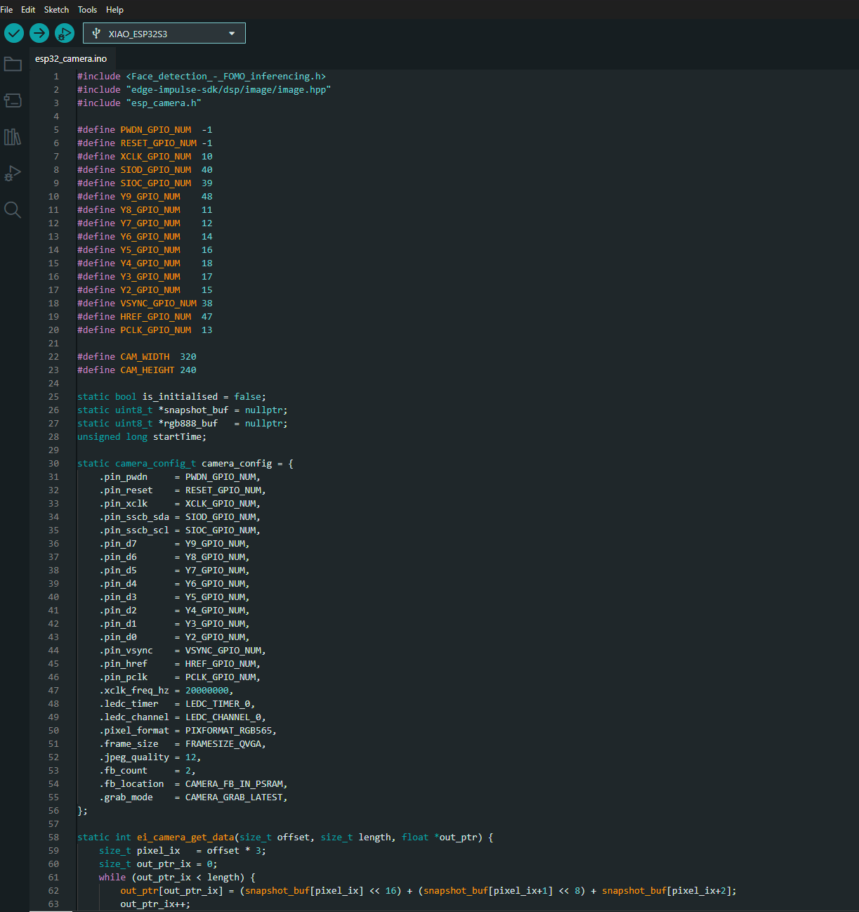

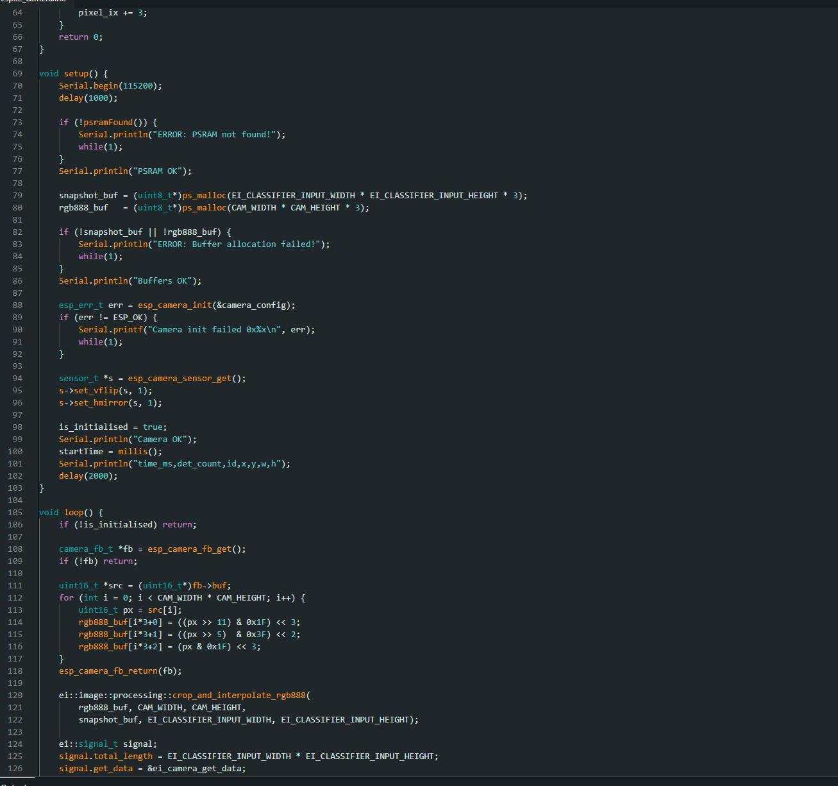
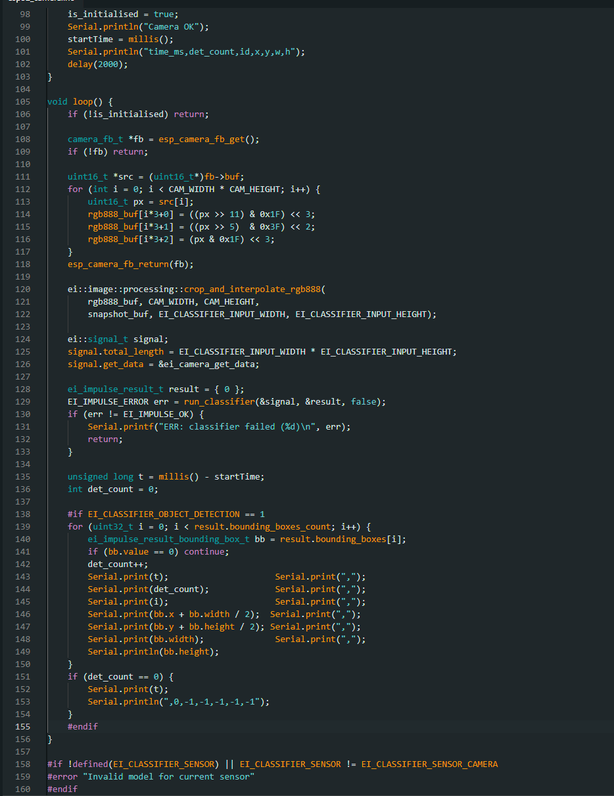

XIAO ESP32-S3 Sense — Platform Limitations, Setup Difficulties, and Implementation Notes
The XIAO ESP32-S3 Sense presented significantly greater setup complexity than HuskyLens. While HuskyLens provided a self-contained hardware AI module with a stable Arduino library and direct I2C output, the XIAO ESP32-S3 required manual toolchain configuration, board package repair, library rebuilding, and repeated debugging across multiple layers of the software stack. Two distinct development paths were attempted before stable benchmarkable output was achieved.
First Approach: VS Code with ESP-WHO and ESP-IDF
The initial development path used Visual Studio Code with the ESP-IDF extension and Espressif’s ESP-WHO computer vision framework. ESP-WHO is Espressif’s dedicated vision library for ESP32 devices and includes pre-built face detection and face recognition pipelines based on HumanFaceDetect and dl::Model inference engines.
Environment configuration: VS Code with ESP-IDF extension, ESP-IDF v5.5.3, ESP-WHO repository cloned at C:\Users\AK\esp-who, XIAO ESP32-S3 Sense target, detected camera: OV3660.
Table 1. ESP-WHO / ESP-IDF Attempt — Stage-by-Stage Outcome
Stage | Outcome | Notes
VS Code + ESP-IDF setup | Success | ESP-IDF v5.5.3 confirmed in terminal. Initial confusion over online vs offline installer resolved.
ESP-WHO clone + IDF_EXTRA_ACTIONS_PATH | Partial success | Required IDF_EXTRA_ACTIONS_PATH = C:\Users\AK\esp-who\tools\ to load BSP and SDKCONFIG defaults correctly.
human_face_recognition — build and flash | Success | Camera detected as OV3660. PSRAM and frame buffers allocated. Model loading confirmed from dl::Model.
human_face_recognition — headless use | Failed | Example designed for ESP32-S3-EYE with LCD. Returned from app_main() rather than entering inference loop.
object_detect example — build | Failed initially | Required explicit -DDETECT_MODEL=human_face_detect flag. Strict command ordering: set-target → build → flash monitor.
Code adaptation (WhoS3Cam) | Failed | WhoS3Cam is not a pipeline node and cannot be inserted using add_node<>. Header mix-ups from different examples caused compile errors.
Second Approach: Arduino IDE with Edge Impulse
Following the abandonment of the ESP-WHO path, development was restarted using Arduino IDE with the Seeed XIAO ESP32-S3 board package and the Edge Impulse Arduino inference library. This path provided a more accessible deployment target and reached stable benchmarkable output after resolving the following issues:
- Wrong default camera pins (ESP-EYE defaults replaced with XIAO-specific GPIO mapping).
- Framebuffer overflow crashes resolved by switching to PIXFORMAT_RGB565 and PSRAM allocation.
- Edge Impulse EON Compiler heap corruption resolved by rebuilding with TensorFlow Lite engine.
- USB CDC On Boot setting required to be enabled for reliable serial logging via PuTTY.
- Partition scheme changed to Huge APP (3MB No OTA/1MB SPIFFS) to accommodate the combined library footprint.
Conclusion
The XIAO ESP32-S3 Sense platform required substantially more setup effort than HuskyLens, involving two abandoned development paths and multiple debugging iterations before stable output was achieved. These setup difficulties are documented as a platform limitation finding, consistent with the study’s methodology of treating setup experience as a measurable research outcome.

XIAO ESP32-S3 Sense Object Classification Test Results
Platform: Seeed XIAO ESP32S3 Sense (OV2640) | Model: Edge Impulse FOMO MobileNetV2 0.35×
Classes: OBJECTA, OBJECTB, OBJECTC + BACKGROUND | Inference resolution: 96×96
The XIAO ESP32-S3 Sense was configured with an Edge Impulse FOMO object-classification model trained on three objects (OBJECTA, OBJECTB, OBJECTC) plus a background class, and deployed via Arduino IDE. The on-board OV2640 camera captured live frames at QVGA resolution (320×240), which were resized to 96×96 for inference. Serial output (time_ms, det_count, class_id, x, y, w, h) was logged in three independent runs (~60 s each) under fixed camera placement and consistent scene conditions.
Logged Fields and Validity Rule
- time_ms — elapsed time from start of logging (ms)
- det_count — number of detections returned at that time step
- class_id — classified object index (OBJECTA = 1, OBJECTB = 2, OBJECTC = 3; −1 when not detected)
- x, y — bounding-box centre (pixels; −1 when not detected)
- w, h — bounding-box dimensions (pixels; −1 when not detected)
A valid detection is any row where class_id ≥ 0 and x, y, w, h ≥ 0.
Run Conditions
- Run 1 (Static): Objects A, B, and C presented sequentially (~20 s each) at fixed distance.
- Run 2 (Negative control): No target objects present.
- Run 3 (Dynamic): Objects moved and swapped during the session.
Run | Scenario | Samples (N) | Duration (s) | FPS | Valid Detections | Detection Rate (%) | Unique IDs | ID Switches
Run 1 | Static (objects A–C) | 421 | 71.210 | 5.898 | 243 | 57.720 | 3 | 111
Run 2 | No target (negative) | 341 | 66.528 | 5.111 | 4 | 1.173 | 1 | 0
Run 3 | Dynamic (motion, swaps) | 418 | 75.503 | 5.523 | 198 | 47.368 | 3 | 86
Table 1. Per-Run Benchmark Summary — Object Classification
Run | x Mean ± SD | y Mean ± SD | w Mean ± SD | h Mean ± SD | x Range | y Range | w / h Range
Run 1 | 43.029 ± 6.802 | 46.255 ± 6.846 | 8.955 ± 2.594 | 8.296 ± 1.511 | 36–68 | 12–84 | 8–16 / 8–16
Run 2 | 24.000 ± 6.928 | 38.000 ± 22.891 | 8.000 ± 0.000 | 8.000 ± 0.000 | 20–36 | 20–76 | 8 / 8
Run 3 | 30.869 ± 15.377 | 43.980 ± 12.748 | 8.162 ± 1.126 | 8.283 ± 1.477 | 4–84 | 4–84 | 8–16 / 8–16
Table 2. Bounding Box Statistics (Valid Detections Only) — Object Classification
Combined Summary
- Total samples: 1,180 over 213.241 s. Weighted average FPS: 5.520 FPS.
- Run 1 (Static): 57.720% detection rate. 111 class switches reflect sequential object presentation with FOMO switching at transition boundaries.
- Run 2 (Negative control): 1.173% false positive rate — 4 spurious detections out of 341 samples, all classified as OBJECTA. Explicitly reported rather than rounded to 0%.
- Run 3 (Dynamic): 47.368% detection rate with 86 class switches across three object classes.
- Overall means (valid): x = 37.447, y = 45.169, w = 8.593, h = 8.288.
- Bounding boxes predominantly 8×8 pixels at 96×96 inference resolution — characteristic of FOMO grid output.
Discussion
Run 1 classification detected all three object classes across the 71.2 s static run. The 111 class switches reflect sequential object presentation (~20 s each), with FOMO producing rapid switching at transition boundaries. Bounding boxes were tightly clustered with small FOMO-characteristic dimensions (predominantly 8×8 pixels). FPS was approximately 5.9.
Run 2 produced 4 spurious valid detections (1.2% false positive rate), all classified as OBJECTA. While HuskyLens achieved 0% false positives in its equivalent negative run, the 4 XIAO detections represent a minor FOMO artefact at low confidence rather than systematic misclassification. This non-zero false positive rate is explicitly documented as a platform finding.
Run 3 produced 198 valid detections from 418 samples (47.4% detection rate) with 86 class switches. The lower detection rate compared to the static run is consistent with FOMO’s sensitivity to motion blur and rapid scene changes on the ESP32-S3’s software-based inference pipeline.
Conclusion
The XIAO ESP32-S3 Sense with Edge Impulse FOMO delivered object-classification outputs at approximately 5.5 FPS — significantly lower than HuskyLens (~42.9 FPS), reflecting the difference between software-based TensorFlow Lite Micro inference on the ESP32-S3 CPU and the hardware-accelerated KPU on the Kendryte K210. The static run confirmed correct three-class detection. The 1.2% false positive rate contrasts with HuskyLens’s 0%. Bounding-box dimensions reflect FOMO’s fixed grid output, consistent with the face detection results on the same platform.

REFENCES

[1] Seeed Studio, 'XIAO ESP32S3 Sense Wiki,' Seeed Studio Documentation, 2023. https://wiki.seeedstudio.com/xiao_esp32s3_getting_started/
[2] Edge Impulse, 'FOMO: Faster Objects, More Objects,' Edge Impulse Documentation, 2022. https://docs.edgeimpulse.com/docs/edge-impulse-studio/learning-blocks/object-detection/fomo-object-detection-for-constrained-devices
[3] Edge Impulse, 'XIAO Face Detection — FOMO Project,' Edge Impulse Studio, 2026. https://studio.edgeimpulse.com/studio/936870
[4] Edge Impulse, 'XIAO Object Classification — FOMO Project,' Edge Impulse Studio, 2026. https://studio.edgeimpulse.com/studio/938172
[5] Espressif Systems, 'ESP32-S3 Series Datasheet,' Espressif Documentation, 2023. https://www.espressif.com/sites/default/files/documentation/esp32-s3_datasheet_en.pdf
[6] Espressif Systems, 'ESP32-S3 Camera Driver (esp_camera),' GitHub — espressif/esp32-camera, 2023. https://github.com/espressif/esp32-camera

#include <XIAO_Object_Classification_inferencing.h>
#include "edge-impulse-sdk/dsp/image/image.hpp"
#include "esp_camera.h"

// XIAO ESP32S3 Sense camera pins
#define PWDN_GPIO_NUM -1
#define RESET_GPIO_NUM -1
#define XCLK_GPIO_NUM 10
#define SIOD_GPIO_NUM 40
#define SIOC_GPIO_NUM 39
#define Y9_GPIO_NUM 48
#define Y8_GPIO_NUM 11
#define Y7_GPIO_NUM 12
#define Y6_GPIO_NUM 14
#define Y5_GPIO_NUM 16
#define Y4_GPIO_NUM 18
#define Y3_GPIO_NUM 17
#define Y2_GPIO_NUM 15
#define VSYNC_GPIO_NUM 38
#define HREF_GPIO_NUM 47
#define PCLK_GPIO_NUM 13

#define CAM_WIDTH 320
#define CAM_HEIGHT 240

static bool is_initialised = false;
static uint8_t *snapshot_buf = nullptr;
static uint8_t *rgb888_buf = nullptr;
unsigned long startTime;

static camera_config_t camera_config = {
.pin_pwdn = PWDN_GPIO_NUM,
.pin_reset = RESET_GPIO_NUM,
.pin_xclk = XCLK_GPIO_NUM,
.pin_sscb_sda = SIOD_GPIO_NUM,
.pin_sscb_scl = SIOC_GPIO_NUM,
.pin_d7 = Y9_GPIO_NUM,
.pin_d6 = Y8_GPIO_NUM,
.pin_d5 = Y7_GPIO_NUM,
.pin_d4 = Y6_GPIO_NUM,
.pin_d3 = Y5_GPIO_NUM,
.pin_d2 = Y4_GPIO_NUM,
.pin_d1 = Y3_GPIO_NUM,
.pin_d0 = Y2_GPIO_NUM,
.pin_vsync = VSYNC_GPIO_NUM,
.pin_href = HREF_GPIO_NUM,
.pin_pclk = PCLK_GPIO_NUM,
.xclk_freq_hz = 20000000,
.ledc_timer = LEDC_TIMER_0,
.ledc_channel = LEDC_CHANNEL_0,
.pixel_format = PIXFORMAT_RGB565,
.frame_size = FRAMESIZE_QVGA,
.jpeg_quality = 12,
.fb_count = 2,
.fb_location = CAMERA_FB_IN_PSRAM,
.grab_mode = CAMERA_GRAB_LATEST,
};

static int ei_camera_get_data(size_t offset, size_t length, float *out_ptr) {
size_t pixel_ix = offset * 3;
size_t out_ptr_ix = 0;
while (out_ptr_ix < length) {
out_ptr[out_ptr_ix] = (snapshot_buf[pixel_ix] << 16) + (snapshot_buf[pixel_ix+1] << 8) + snapshot_buf[pixel_ix+2];
out_ptr_ix++;
pixel_ix += 3;
}
return 0;
}

void setup() {
Serial.begin(115200);
delay(1000);

if (!psramFound()) {
Serial.println("ERROR: PSRAM not found!");
while(1);
}
Serial.println("PSRAM OK");

snapshot_buf = (uint8_t*)ps_malloc(EI_CLASSIFIER_INPUT_WIDTH * EI_CLASSIFIER_INPUT_HEIGHT * 3);
rgb888_buf = (uint8_t*)ps_malloc(CAM_WIDTH * CAM_HEIGHT * 3);

if (!snapshot_buf || !rgb888_buf) {
Serial.println("ERROR: Buffer allocation failed!");
while(1);
}

esp_err_t err = esp_camera_init(&camera_config);
if (err != ESP_OK) {
Serial.printf("Camera init failed 0x%x\n", err);
while(1);
}

sensor_t *s = esp_camera_sensor_get();
s->set_vflip(s, 1);
s->set_hmirror(s, 1);

is_initialised = true;
Serial.println("Camera OK");
startTime = millis();
Serial.println("time_ms,det_count,class_id,x,y,w,h");
delay(2000);
}

void loop() {
if (!is_initialised) return;

camera_fb_t *fb = esp_camera_fb_get();
if (!fb) return;

uint16_t *src = (uint16_t*)fb->buf;
for (int i = 0; i < CAM_WIDTH * CAM_HEIGHT; i++) {
uint16_t px = src[i];
rgb888_buf[i*3+0] = ((px >> 11) & 0x1F) << 3;
rgb888_buf[i*3+1] = ((px >> 5) & 0x3F) << 2;
rgb888_buf[i*3+2] = (px & 0x1F) << 3;
}
esp_camera_fb_return(fb);

ei::image::processing::crop_and_interpolate_rgb888(
rgb888_buf, CAM_WIDTH, CAM_HEIGHT,
snapshot_buf, EI_CLASSIFIER_INPUT_WIDTH, EI_CLASSIFIER_INPUT_HEIGHT);

ei::signal_t signal;
signal.total_length = EI_CLASSIFIER_INPUT_WIDTH * EI_CLASSIFIER_INPUT_HEIGHT;
signal.get_data = &ei_camera_get_data;

ei_impulse_result_t result = { 0 };
EI_IMPULSE_ERROR err = run_classifier(&signal, &result, false);
if (err != EI_IMPULSE_OK) {
Serial.printf("ERR: classifier failed (%d)\n", err);
return;
}

unsigned long t = millis() - startTime;
int det_count = 0;

#if EI_CLASSIFIER_OBJECT_DETECTION == 1
for (uint32_t i = 0; i < result.bounding_boxes_count; i++) {
ei_impulse_result_bounding_box_t bb = result.bounding_boxes[i];
if (bb.value == 0) continue;
if (String(bb.label) == "BACKGROUND") continue;
det_count++;
int class_id = -1;
if (String(bb.label) == "OBJECTA") class_id = 1;
else if (String(bb.label) == "OBJECTB") class_id = 2;
else if (String(bb.label) == "OBJECTC") class_id = 3;

Serial.print(t); Serial.print(",");
Serial.print(det_count); Serial.print(",");
Serial.print(class_id); Serial.print(",");
Serial.print(bb.x + bb.width / 2); Serial.print(",");
Serial.print(bb.y + bb.height / 2); Serial.print(",");
Serial.print(bb.width); Serial.print(",");
Serial.println(bb.height);
}
if (det_count == 0) {
Serial.print(t);
Serial.println(",0,-1,-1,-1,-1,-1");
}
#endif
}

#if !defined(EI_CLASSIFIER_SENSOR) || EI_CLASSIFIER_SENSOR != EI_CLASSIFIER_SENSOR_CAMERA
#error "Invalid model for current sensor"
#endif

